1. **E-commerce Platform Search Function**

**Program:**

**Product.java**

import java.util.*;  
  
class Product {  
 int productId;  
 String productName;  
 String category;  
  
 public Product(int productId, String productName, String category) {  
 this.productId = productId;  
 this.productName = productName;  
 this.category = category;  
 }  
  
 public String toString() {  
 return "ID: " + productId + ", Name: " + productName + ", Category: " + category;  
 }  
}

**ProductSearchDemo.java**

import java.util.Arrays;  
import java.util.Comparator;  
  
public class ProductSearchDemo {  
  
  
 public static Product linearSearch(Product[] products, String targetName) {  
 for (Product p : products) {  
 if (p.productName.equalsIgnoreCase(targetName)) {  
 return p;  
 }  
 }  
 return null;  
 }  
  
 public static Product binarySearch(Product[] products, String targetName) {  
 int left = 0, right = products.length - 1;

while (left <= right) {  
 int mid = (left + right) / 2;  
 int cmp = products[mid].productName.compareToIgnoreCase(targetName);  
 if (cmp == 0) return products[mid];  
 else if (cmp < 0) left = mid + 1;  
 else right = mid - 1;  
 }  
 return null;  
 }  
  
 public static void main(String[] args) {  
 Product[] products = {  
 new Product(101, "Laptop", "Electronics"),  
 new Product(102, "Shoes", "Fashion"),  
 new Product(103, "Smartphone", "Electronics"),  
 new Product(104, "Watch", "Accessories"),  
 new Product(105, "Backpack", "Fashion")  
 };  
  
 String searchName = "Watch";  
 Product result1 = *linearSearch*(products, searchName);  
 System.*out*.println("Linear Search Result:");  
 System.*out*.println(result1 != null ? result1 : "Product not found");  
  
 Arrays.*sort*(products, Comparator.*comparing*(p -> p.productName.toLowerCase()));  
  
 Product result2 = *binarySearch*(products, searchName);  
 System.*out*.println("\nBinary Search Result:");  
 System.*out*.println(result2 != null ? result2 : "Product not found");  
 }  
 }

**Output:**

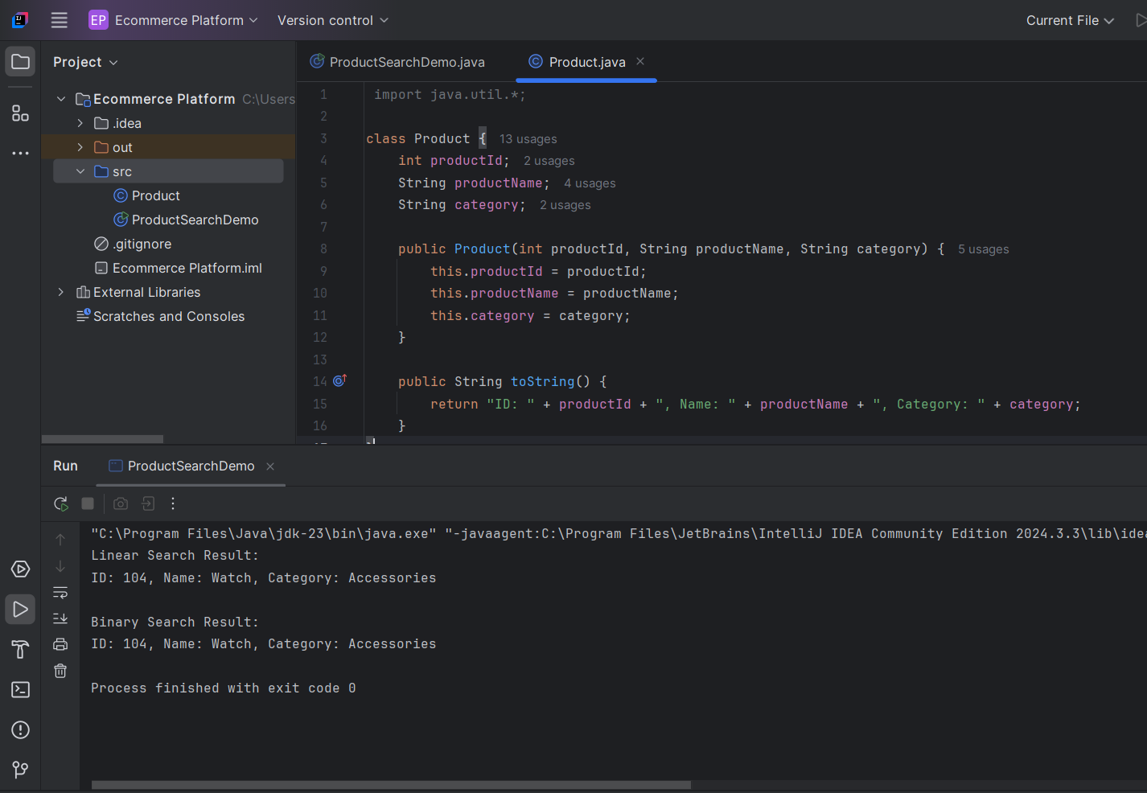

**2. Financial Forecasting**

**Program:**

**FinancialForecast.java**

public class FinancialForecast {  
 public static double futureValue(double currentValue, double rate, int years) {  
 if (years == 0) {  
 return currentValue;  
 }  
 return *futureValue*(currentValue, rate, years - 1) * (1 + rate);  
 }  
  
 public static void main(String[] args) {  
 double initialInvestment = 10000;  
 double growthRate = 0.08;  
 int years = 5;  
  
 double futureAmount = *futureValue*(initialInvestment, growthRate, years);  
 System.*out*.printf("Predicted future value after %d years: ₹%.2f\n", years, futureAmount);  
 }  
}

**output:**

